Electrical Signals 1

Sodium-Potassium Pump
The diagram shows the sodium-potassium pump at work. Describe what is happening in each box. Identify the ions (name and number) and direction of movement (influx, efflux).

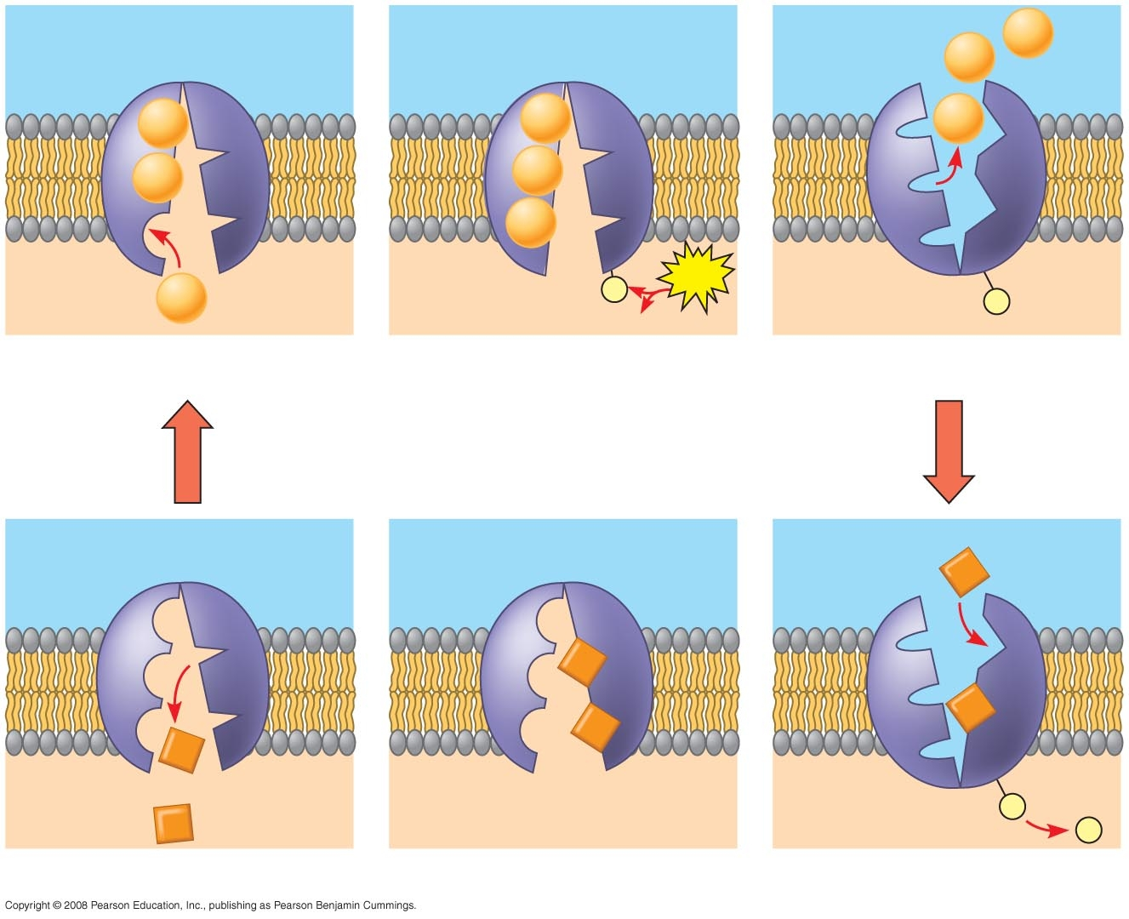
1
2
3
4
5
6

1. ______________________________________________________

2. ______________________________________________________

3. ______________________________________________________

4. ______________________________________________________

5. ______________________________________________________

6. ______________________________________________________
Resting Membrane Potential (RMP)

The diagram below shows the overall charge (potential) on the resting membrane of a neuron. Add these things to the diagram:
● Cations (Na⁺, K⁺)
● Their relative concentrations (high, low).

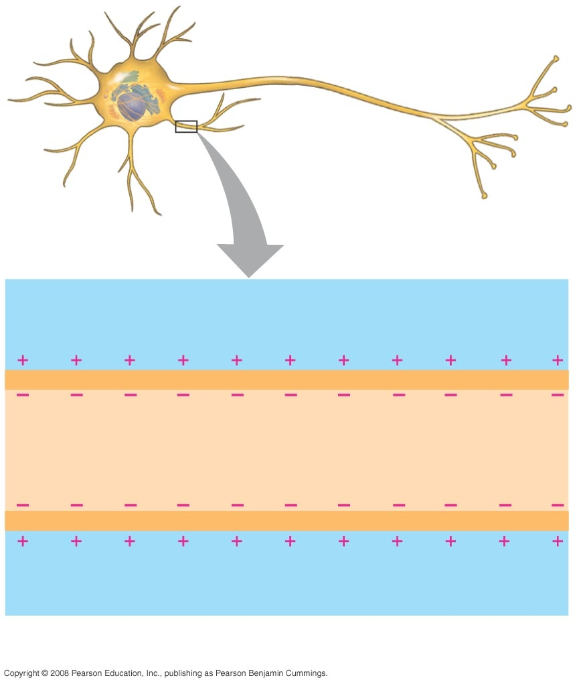
Action Potential
Identify the stages in this diagram. For each stage, identify which ion is moving and its direction (influx, efflux).

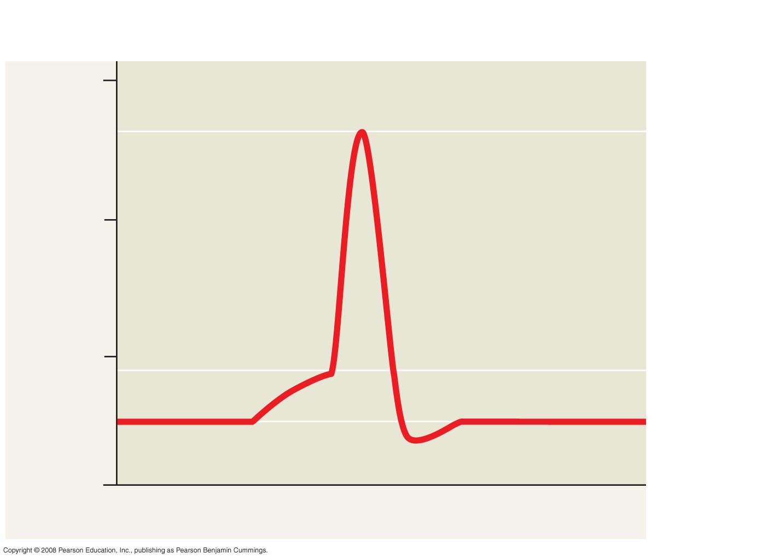
1
2
3
4
5
6

Stages: Ion Movement:

1. ___________________________ ___________________________

2. ___________________________ ___________________________

3. ___________________________

4. ___________________________ ___________________________

5. ___________________________ ___________________________

6. ___________________________ ___________________________

7. What are the units on the x axis? ___________________________

8. What are the units on the y-axis? ___________________________
Voltage-Gated Channels on Axons

Fill in the blanks with the appropriate terms
Channels: Use a term that describes the condition of the channel:
Open
Opening quickly
Opening slowly
Closed and inactivated
Closing slowly

Influx/Efflux: Name the ion.

Inside of Membrane: What is the charge of the membrane at this phase?

Depolarization
Na⁺ channels _________________

K⁺ channels _________________

Influx of: _________________

Inside of membrane is becoming _________ charged with respect to the outside.

Repolarization
Na⁺ channels _________________

K⁺ channels _________________

Efflux of: _________________

Inside of membrane is becoming _________ charged with respect to the outside.

Hyperpolarization
Na⁺ channels Closed and Activated

K⁺ channels _________________

Inside of membrane is _________________ charged with respect to the outside.

